Sri Lanka Institute of Information

Technology



Lab Submission

Lab sheet No 4

**IT24100082**

**Sanjula.B.A.S.**

**Probability and Statistics | IT2120**

B.Sc. (Hons) in Information Technology

Exercise

1

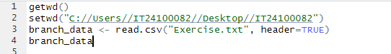

2. Identify the variable type and scale of measurement for each variable

Team – Categorical (Nominal)

Team Attendance (X1) – Quantitative (Ratio)

Team Salary (X2) – Quantitative (Ratio)

Years (X3) – Quantitative (Ratio, discrete)

3.



4.



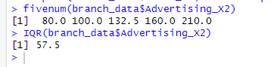

5.

